**ABSTRACT**

A submersible pump is a device which has motor close-coupled to the pump body. The whole assembly is submerged in the fluid to be pumped.

The main advantage of this type of pump is that it prevents pump cavitations, a problem associated with a high elevation difference between pump and the fluid surface. Submersible pumps push fluid to the surface as opposed to jet pumps having to pull fluids.

Submersible pumps are found in many applications. Single stage pumps are used for drainage, sewage pumping, general industrial pumping and slurry pumping. They are also popular with aquarium filters. Multiple stage submersible pumps are typically lowered down a borehole and used for water abstraction, water wells and in oil wells.

“Importance of PROBLEM WITH ITS BRIEF AND SOLUTION”

M/s. J.V Industry, a well known company established at Visnagar is manufacturing various types of within range from 0.5 HP/0.37 kW to 150 HP/112kw.

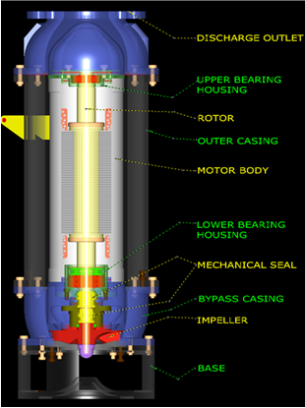

**SWAMI SACHCHIDANAND POLYTECHNIC**

**COLLEGE, VISNAGAR.**

**384315**

**INDEX**

|  |  |
| --- | --- |
| **SR.NO.** | **TOPIC** |
| 1 | Chapter-1  Company Profile |
| 2 | Chapter-2  Submersible Pump |
| 3 | Chapter-3  Introduction about I.D.P. |
| 4 | Chapter-4  Detail Description of I.D.P. |
| 5 | Chapter-5  Expected Outcome |
| 6 | Chapter-6 Conclution |
| 7 | Chapter-7 Referance |

***1. Company Profile***

**1.1 Introduction**

As a part of Project -1 subject, we visited Amrut Engineering Pvt Ltd situated in Visnagar. It is medium scale, private limited organization. It is one of the leading Manufactures in India and Exporters of submersible pump and mono block pumps sets to African Countries, UAE, Bangladesh, Sri Lanka, Nepal, Sudan, Morocco, South East Asian Countries etc.

Amrut Engineering Pvt Ltd has made huge investment in plant & latest machinery, implementation of their R&D Department and maintenance of international quality system. They believe in 100% customer satisfaction as Quality and Customers are their major strength. Their continuous research and up gradation of their latest technology in the filed of Submersible Pump and Mono Block Pump manufacturing industry helps them to grow as one of the major supplier.

Amrut Engineering Pvt Ltd strongly believes in periodical maintenance of International Quality Systems and Implementation of latest Technologies. Company have fully equipped with measuring instruments and tooling machines at machine shop to ensure standardization of products.They have established Quality Management System in accordance with ISO 9001:2008.

* 1. **Company Address**

|  |  |
| --- | --- |
| **Corporate office** | **Industry** |
| Post Box No 4141, Second Floor,Motilal Centre, Near Dinesh Hall, Ashram Road, Ahmedabad-380009  Phone No: +91 79 27546932.  Email: [amrutpump@jindalonline.net](mailto:amrutpump@jindalonline.net) | 115/1-2, GIDC Estate,  Kansa Road,  Visnagar - 384315  Dist.Mehsana, Gujarat  Phone No: (02765) 220840  Email: [amrutpump@jindalonline.net](mailto:amrutpump@jindalonline.net) |

**1.3 History**

A part from the struggle that took place in the life of MR.A.L.PATEL, the present managing director, finally visualized the need and demand of submersible pump in this area. In 1972, he finalized dealership of ATLANTA pumps with one working partner in MR.S.J.PATEL, in name of M/S. AMRUT TRADERS at Visnagar. After three years i.e. in 1975 he started repair workshop in order to render effective after sales services to his clients. In 1977 he started assembly of submersible pump set with few spares purchased from the market.

1978, he started of own manufacturing activities in the same location and inducted AMRUT brand submersible pump set successfully and manufactured 227 sets in first year and 329 sets in second year. The production was restricted up to 15 HP in V6 frame size and up to 45 HP in V8 frame Amrut engineering co. Two more working partners in Mr. M. Sheth for technical matters were inducted in the organization.

In 1984, started another firm and started of AMRUT and EMPIRE brand pump sets from corporate office in swastick super market, Ahmadabad. Finally shifted this firm 1987 in present location in name of Amrut engineering Pvt. Ltd, 115/1-2GIDC Estate, Kansa road in the area of 10400 sq meters and started full fledge manufacturing factory along with 20 anciliaries. Amrut engineering was established located at Ahmadabad, keeping the same AMRUT brand name. Presently we have registered capacity up to 150 hp and 900 sets per shift per month. But installed capacity has been such that conveniently we can give 1600 sets per shift per month from this capacity.

* 1. **Organization**

Organization establishes the pattern of relationship by giving duties and responsibility to an individual or group. In the same concerned, Amrut Engg. Pvt ltd has decided management as well as production organization as describe next.

* + 1. **Management Organization**

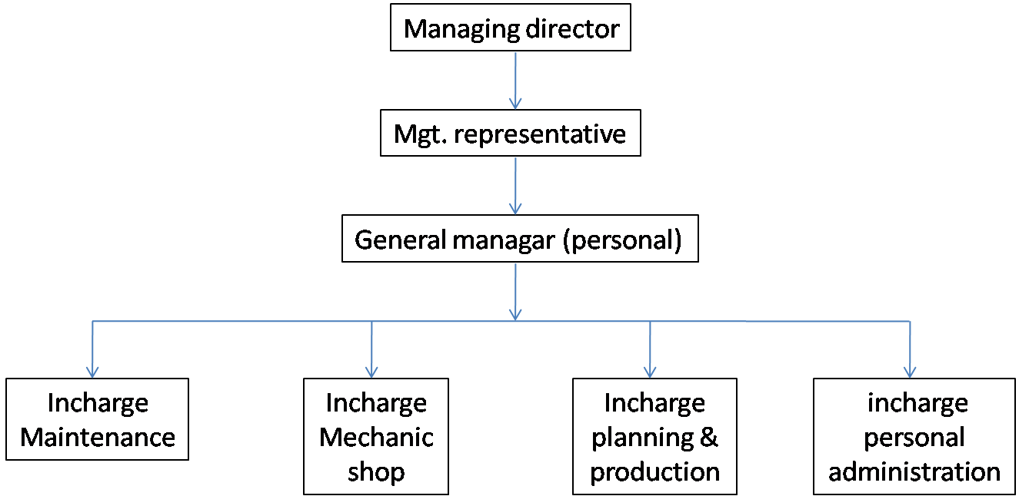

* + 1. **Production Department**

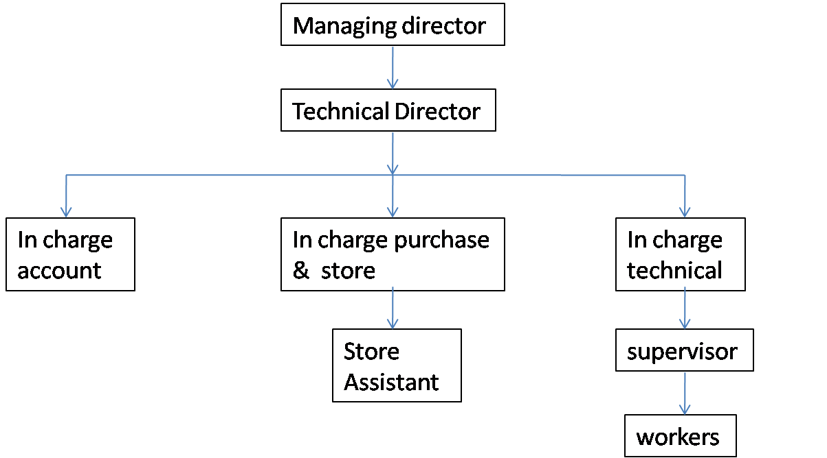

* 1. **Company Product**

Company is manufacturing various products with efficient quality. The next is the detail of the products and its specification.

* + 1. **Vertical Submersible Pump**

The vertical submersible pump is used to lift the water from the dip well. The main use of it is to supply water for farming. Figure 1.1 shows the vertical submersible pump. Table 1.1 shows the specification of the concerned.

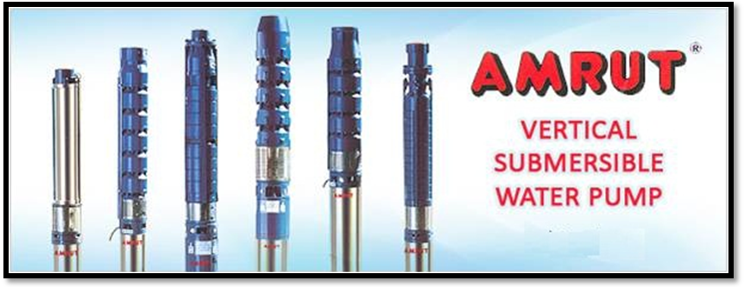

|  |  |  |  |
| --- | --- | --- | --- |
|  | **Head Range**  **(In Meter)** | **Discharge**  **(In LPM)** | **Horse Power**  **(HP)** |
| **V3" Dia. (80 mm)** | 12 to 75 | 30 to 65 | 0.5 to 1.5. |
| **V4" Dia. (100 mm)** | 2 to 190 | 30 to 300 | 2 to 6 |
| **V5" Dia. (125 mm)** | 13 to 63 | 480 | 3 to 12.5 |
| **V6" Dia. (150 mm)** | 17 to 439 | 90 to 1000 | 2 to 30 |
| **V7" Dia. (175 mm)** | 8 to 80 | 1400 to 1600 | 5 to 30 |
| **V8" Dia. (200 mm)** | 8 to 247 | 500 to 1860 | 5 to 75 |
| **V10" Dia. (250 mm)** | 18 to 200 | 1700 to 9000 | 30 to 150 |
| **V12" Dia. (300 mm)** | 25 to 200 | 9000 to 13000 | 80 to 150 |

* + 1. **Horizontal Submersible Water Pump**

Horizontal submersible water pump is used to supply the water for High rise Buildings, Bungalows / Housing Colonies, Sprinkler Systems, Cooling Plants

Fountains, Riverbed, Sump / Jack well, Fire Fighting Systems, Canals, Open Wells, and Lift Irrigation. Figure 1.4 shows horizontal submersible pump. Table 1.2 shows the specification of the concerned.

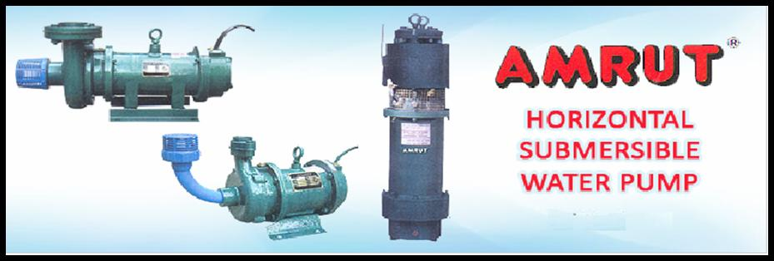

Horizontal Submersible Pumps

**Specification Horizontal Submersible Water Pump**

|  |  |  |
| --- | --- | --- |
|  | **Horizontal type Submersible Monoset** | **Vertical type Submersible Monoset** |
| **Head Range:** | 18 Meter to 100 Meter | 18 Meter to 100 Meter |
| **Discharge:** | 400 LPM to 4000 LPM | 400 LPM to 4000 LPM |
| **Horse Power:** | 0.5 H.P. to 80 H.P. | 0.5 H.P. to 30 H.P. |

* + 1. **De Watering Drainage Water Pump**

Dewatering drainage water pump is used to discharge the drainage of wastage water which has been already utilized in the process industries. Figure 1.5 shows the De Watering Drainage Water Pump. Table 1.2 describes the specification of the same.

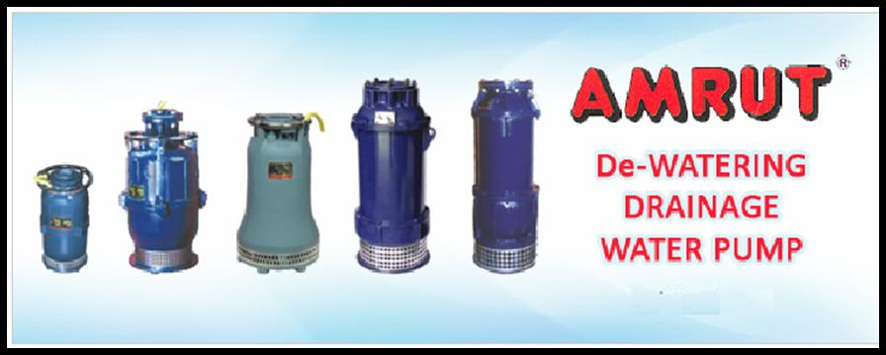

**De Watering Drainage Water Pump**

**Specification De Watering Drainage Water Pump**

|  |  |  |
| --- | --- | --- |
| **Specification** | **Submersible Waste Water Pump** | **Submersible De-Watering Pump** |
| **Head Range** | Up to 50 meter | Up to 120 meter |
| **Discharge** | Up to 15000 LPM | Up to 15000 LPM |
| **Horse Power** | 0.75 to 55 KW | 0.55 to 55 KW |
| **Motor** | Oil filled Vertical | Oil filled Vertical |
| **Winding** | PVC Insulated | PVC Insulated |
| **RPM** | 1450 / 2900 | 1450 / 2900 |
| **Supply** | Signal Phase (160/230V. 50Hz.)  Three Phase (320/440V. 50Hz.) | Single Phase (160/230V. 50Hz.)  Three Phase (320/440V. 50Hz.) |

**1.6 Factory Layout**

The factory layout is the primary tool required to carry on production and into which all other production tool, processes and mechanisms must fit.

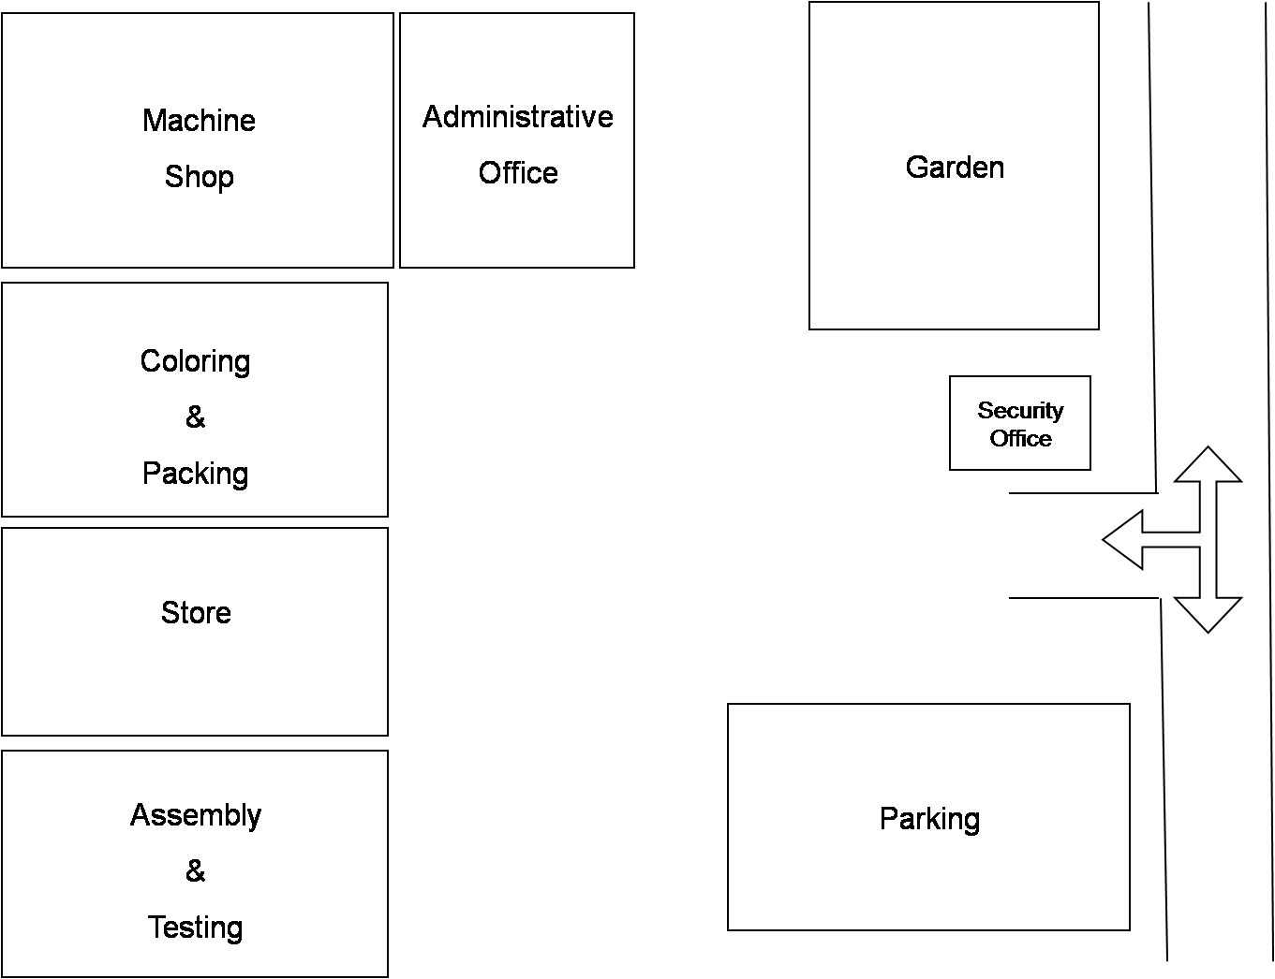

**Factory Layout**

**1.6.1 Production Processes**

Process planning means the preparation of work detail plan. Process planning is determine the most economical method of performing an operation or activity.The departmetal manufacturing process is been given a close watch through measuring of critical parameters as per its application in work instruction quality plan and its detail regarding is given below:

* **Machine Shop**

In the machine shop certain operations take place, Turning, Keywey, Driiing, Tapping, Brazing, Shrink, Fitting, Vacuum impregnatio (varnishing), Dynamic balancing of rotor & impellor, Powder coating.

* **Pump Assembly**

In the pump assembly the assorted sizes of pumps are assembled.

* **Motor Assembly**

In the motor assembly the assembling of motor, stator winding, joints is carried out.

* **Final Testing**

In the final testing the testing of the pump and moters are done thoroughly and tested to ensure that the product confirm to specified requirement.

* **Dispatch**

In dispatch the pump and motors are painted, accessories, fitting and packing for product is being carried out.

* **Electric load**  D.G set to meet the emergency requirement of power. The company has go sanction of power of 150 HP from Gujarat electricity board and having installed 125 KVA.

**1.6.2 Production Process Chart**

Process chart indicate the sequence of event, they do not illustrate the moments of men, material, etc., while the work is being accomplished.

The number of moment is minimized, result in a lot of saving both in cost as well as effort required to do the job.

The part of moment can be batter visualized buy drawing a diagram.

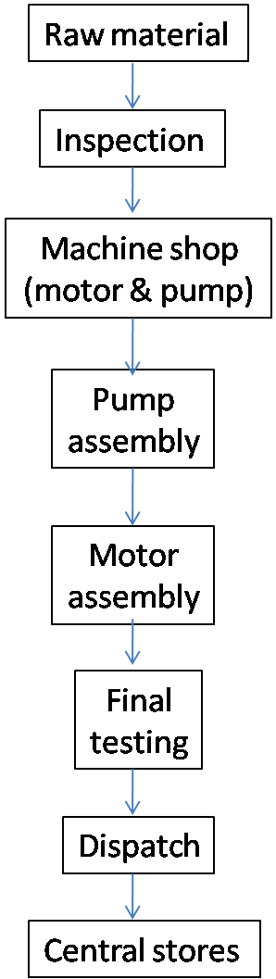

Production Process Chart

**1.6.3 Production Department**

Production department layout implies that various operations on raw material are performed in a sequence and the machines are placed along the product flow line.

This type of layout is preferred for continuous production, i.e., involving a continuous flow of in-process material towards the finished product stage.

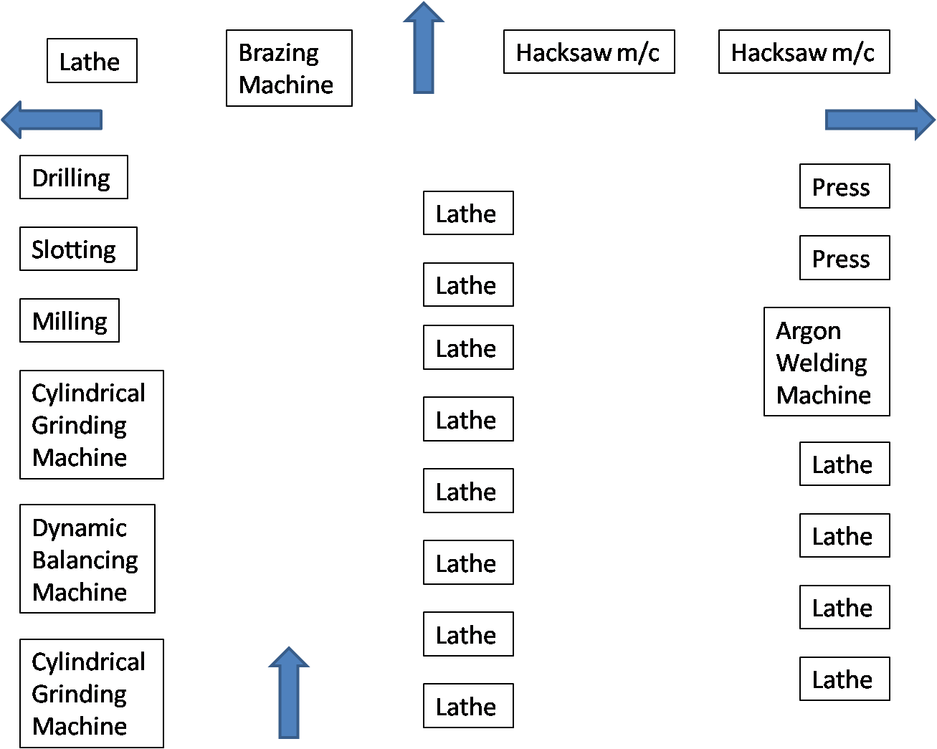

**Flow Chart of Production Department**

**1.6.4 List & Manufacturer Of Machinery**

The details of manufacturees of the machineries are given below:

**Manufacturees of The Machineries**

|  |  |  |  |
| --- | --- | --- | --- |
| **Sr. NO** | **NAME OF MACHINORY** | **MANUFACTURER** | **QUANTITY**  **NOS.** |
| **1** | Centre Lathes | H.M.T.Turrent Kirloskar Cemoga, Tiger | 16 |
| **2** | Cylindrical Grinding | Smithson | 2 |
| **3** | Vertical Milling | H M T Sunrise | 2 |
| **4** | Collumn Drilling | S K P Mew Perfect | 4 |
| **5** | Dynamic Balancing | Blue Star | 2 |
| **6** | Hydralic Press | Work Well Engineering | 3 |
| **7** | Hacksaw | Vishal/sahyog | 3 |
| **8** | Slotting | Sunrise | 1 |
| **9** | Tapping |  | 1 |
| **10** | Power Coaching | Sepl | 1 |
| **11** | Buffing | Bharat Engineering | 1 |
| **12** | Argone Welding | Sisireng | 1 |

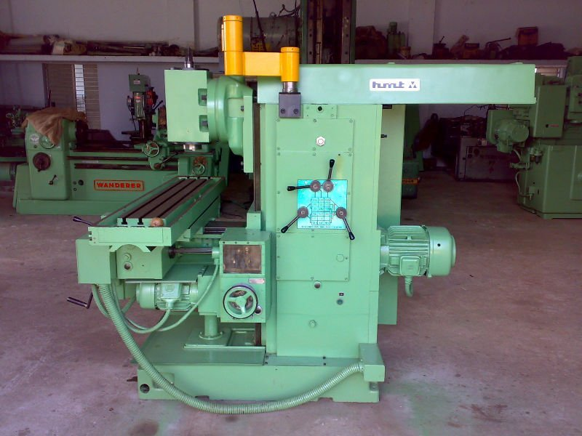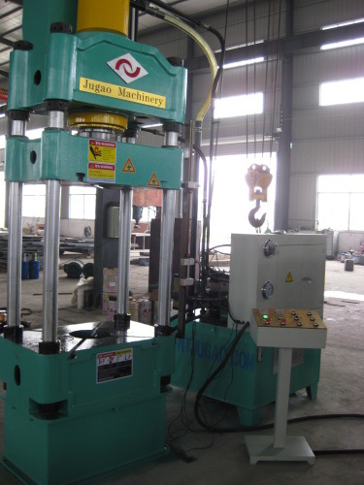

**Vertical milling machine Hydralic press machi**

* + 1. **Machine Specification**

**Machine Specification**

|  |  |  |  |
| --- | --- | --- | --- |
| **Sr No.** | **Particular** | **Detail of Particular** | **Specification** |
| **1** | Capacities | Height of centers | 220 mm |
| Type of bed | Straight |
| Swing over bed | 500 mm |
| Swing over cross slide | 270 mm |
| Swing over carriage wing | 480 mm |
| Swing in gap | 720 mm |
| **2** | Headstock | Spindle nose/bore | A 2 – 6/53 mm |
| Spindle socket taper | metric 60/53 mm |
| Speed range | 40 – 2040 forward  60 – 2375 reverse |
| **3** | Feeds and threads | Feed range longitudinal | 0.04–2.24 mm/rev |
| Feed range cross | 0.02–1.12 mm/rev |
| Lead screw pitch | 6 mm |
| Metric thread | 0.5 – 28 mm |
| Inch thread | 56 – 1 TPI |
| **4** | Carriage | Cross slide travel | 300 mm |
| Top slide travel | 150 mm |
| Tool shank size | 25 * 25 mm*mm |
| **5** | Tail stock | Sleeve diameter | 90/MT5 mm |
| Sleeve travel | 200 mm |
| **6** | General | Power of main motor | 11 kw |
| Distance between centers | 3000 mm |
| Weight net (approx) | 3150 kg |

***2. Submersible Pump***

**2.1 Introduction**

The selection of type and construction of a pump is very important to meet the process specification and proper application. Pumps are devices that impart a pressure increase to a liquid. The pressure rise found in pumps can vary tremendously, which is a very important design parameter along with the liquid flow rate. This pressure rise can range from simply increasing the elevation of the liquid to increasing the pressure hundreds of atmospheres. The application of pumps basically requires knowledge of fluid flow fundamentals.

In today’s industry, the used of pumps may be classified in two general types, centrifugal (dynamic) and positive displacement pumps. Positive displacement pumps work by allowing a fluid to flow into some enclosed cavity from a low-pressure source, trapping the fluid, and then forcing it out into a high-pressure receiver by decreasing the volume of the cavity. Examples are fuel and oil pump in most automobiles, the pumps on most hydraulic systems and the heart of most animals. The general types of the positive displacement pumps are as below:

**2.2 Reciprocating Pump**

Reciprocating pumps create and displace a volume of liquid, their “displacement volumes”, by action of a reciprocating element. Liquid discharge pressure is limited only by strength of structural parts. A pressure relief valve and a discharge check valve are normally required for reciprocating pumps. Reciprocating pumps can be further classified into three types of pump as below,

i) Piston Pumps

ii) Packed Plunger Pumps

iii) Diaphragm Pumps

**2.3 Rotary Pump**

Rotary pumps function with close clearances such that a fixed volume of liquid is displaced with each revolution of the internal element. Rotary pumps

Included

i) Gear Pump, ii) Lobe Pump

iii) Vane Pumps iv) Screw Pumps

Centrifugal pumps are dynamic pumps. A centrifugal pump raises the pressure of the liquid by giving it a high kinetic energy and then converting that kinetic energy to work. It normally consists of an impeller (a wheel with blades), and some form of housing with a central inlet and a peripheral outlet. The impeller is mounted on a rotating shaft and enclosed in a stationary casing. Casings are generally of two types: volute and circular. The impeller design and the shape of the casing determine how liquid is accelerated though the pump. The general types of the centrifugal pumps are as below.

**2.4 Vertically suspended pump**

A pump with the impeller(s) cantilevered vertically and the suction nozzle typically submerged is classified as a vertically suspended pump.

**2.4.1 Seal less pump**

Seal less pumps are special pumps which do not require shaft seals. Seal less pumps have two types which are canned motor and magnetic drive. It normally used in process involve extremely hazardous fluid which leakage is cannot be tolerated.

**2.4.2 Submersible pump**

Submersible pumps are designed for the pump and inside driver components are completely surrounded by the pumped fluid.

**2.5 Horizontal self-priming pump**

Horizontal self-priming pumps are designed to create a vacuum at the pump inlet. This enables the pump to “suck” fluid into its casing. The suction nozzle of the pump can therefore be located above the level of liquid being pumped.

Centrifugal pumps are used in more industrial applications than any other kind of pump. This is primarily because these pumps offer low initial and upkeep costs. Traditionally these pumps have been limited to low-pressure-head applications, but modern pump designs have overcome this problem unless very high pressures are required. The single-stage, horizontal, overhung, centrifugal pump is by far the most commonly type used in the chemical process industry.

Basically, pump selection is made on the flow rate and head requirement and with other process considerations, such as material of the construction pumps for the corrosive chemical service or for the fluid with presence solids in the stream.

**2.6 Important Terminology of Pumps**

**Bearing Housing -**The bearing housing encloses the bearings mounted on the shaft. The bearings keep the shaft or rotor in correct alignment with the stationary parts under the action of radial and transverse loads. The bearing house also includes an oil reservoir for lubrication, constant level of oil, jacket for cooling by circulating cooling water.

**Capacity -** Is the water handling capability of a pump commonly expressed as either gallon per minute (gal/min) or cubic meter per minute (m3/min).

**Cavitations -** Is the result of vapor bubbles imploding? This occurs when the amount of fluid flowing into the pump is restricted or blocked.

**Discharge Port -** Point where the discharge hose or pipe is connected to the pump.

**Datum Elevation –** It use as reference of the horizontal plane for which all the elevations and head are measured. The pumps standards normally specify the datum position relative to a pump part, e.g. Centrifugal horizontal pump datum position is at the impeller shaft centerline.

**Dynamic Discharge Head-** The static discharge head plus the friction in the discharge line also referred to as Total Discharge Head.

**Dynamic Suction Head -** The static suction lift plus the friction in the suction line also referred to as Total Suction Head.

**Endurance limit –** Is the stress below which the shaft will withstand an infinite number of stress reversals without failure. Since one stress reversal occurs for each revolution of the shaft, this means that ideally the shaft will never fail if the maximum bending stress in the shaft is less than the endurance limit of the shaft material.

**Friction Head-**The head required to overcome the resistance to flow in the pipe and fittings. It is dependent upon the size, condition and type of pipe, number and type of pipe fittings, flow rate, and nature of the liquid.

**Friction Loss -** Refers to reductions in flow due to turbulence as water passes through hoses, pipes, fittings and elbows.

**Impeller —** A disk with multiple vanes. It is attached to the pump engine or motor and is used to create the centrifugal force necessary for moving water through the pump casing.

**Mechanical Seal —** A common wear part that forms a seal between the pump and the engine or motor. Also prevents liquid from seeping into the engine or motor.

**Net Positive Suction Head (NPSH) -** Is the total head at the suction flange of the pump less the vapor pressure converted to fluid column height of the liquid

**Net Positive Suction Head Required (NPSHR) -** NPSH in meters (feet) determined by Supplier testing, usually with water. NPSHR is measured at the suction flange and corrected to the datum elevation. NPSHR is the minimum NPSH at rated capacity required to prevent a head drop of more than 3% (first stage head in multistage pumps) due to cavitations within pump.

**Pressure Head -** Pressure Head must be considered when a pumping system either begins or terminates in a tank which is under some pressure other than atmospheric. The pressure in such a tank must first be converted to feet of liquid. Denoted as hp, pressure head refers to absolute pressure on the surface of the liquid reservoir supplying the pump suction, converted to feet of head. If the system is open, hp equals atmospheric pressure head

**Static Suction Head -**Head resulting from elevation of the liquid relative to the pump center line (datum). If the liquid level is above pump centerline (datum), is positive. If the liquid level is below pump centerline (datum), is negative. Negative condition is commonly denoted as a “suction lift” condition

**Static Discharge Head -** It is the vertical distance in feet between the pump centerline and the point of free discharge or the surface of the liquid in the discharge tank.

**Suction Port —** Point where the suction hose or pipe is connected to the pump.

**Vapor Pressure Head -** Vapor pressure is the absolute pressure at which a liquid and its vapor co-exist in equilibrium at a given temperature. The vapor pressure of liquid can be obtained from vapor pressure tables. When the vapor pressure is converted to head, it is referred to as vapor pressure head, hvp. The value of hvp of a liquid increases with the rising temperature and in effect, opposes the pressure on the liquid surface, the positive force that tends to cause liquid flow into the pump suction i.e. itreduces the suction pressure head. (Vapor pressure can be said as the externalpressure require to prevent fluid from evaporate become vapor).

**Velocity Head -** Refers to the energy of a liquid as a result of its motion at some velocity ‘v’. It is the equivalent head in feet through which the water would have to fall to acquire the same velocity, or in other words, the head necessary to accelerate the water. The velocity head is usually insignificant and can be ignored in most high head systems. However, it can be a large factor and must be considered in low head systems.

**Viscosity —** is a mechanist of fluid resistance to flow of a liquid at a given temperature. High viscosity liquids such as motor oil are more resistant to flow than water.



**Volute —** A stationary housing inside the pump housing in which the impeller rotates. It is used to separate air and water.

**Total Head -** Pressure required in feet (meter) of head that the pump must produce. The head at the discharge pump flange minus the head at suction flange.

**2.7 Material for Various Parts of Pump and Motor**

The basis of materials science involves relating the desired [properties](http://en.wikipedia.org/wiki/Physical_property) and relative performance of a material in a certain application to the structure of the atoms and phases in that material through characterization. The major determinants of the structure of a material and thus of its properties are its constituent chemical elements and the way in which it has been processed into its final form. These characteristics, taken together and related through the laws of [thermodynamics](http://en.wikipedia.org/wiki/Thermodynamics), govern a material’s [microstructure](http://en.wikipedia.org/wiki/Microstructure), and thus its properties.

The manufacture of a perfect [crystal](http://en.wikipedia.org/wiki/Crystal) of a material is currently physically impossible. Instead materials scientists manipulate the [defects](http://en.wikipedia.org/wiki/Crystallographic_defect) in crystalline materials such as [precipitates](http://en.wikipedia.org/wiki/Precipitates), grain boundaries ([Hall–Petch relationship](http://en.wikipedia.org/wiki/Hall%E2%80%93Petch)), interstitial atoms, vacancies or substitution atoms, to create materials with the desired properties.

Not all materials have a regular crystal structure. [Polymers](http://en.wikipedia.org/wiki/Polymers) display varying degrees of crystalline, and many are completely non-crystalline. [Glasses](http://en.wikipedia.org/wiki/Glass), some ceramics, and many natural materials are [amorphous](http://en.wikipedia.org/wiki/Amorphous_solid), not possessing any long-range order in their atomic arrangements. The study of polymers combines elements of chemical and statistical thermodynamics to give thermodynamic, as well as mechanical, descriptions of physical properties.

**Material For Various Parts of Pump**

|  |  |  |
| --- | --- | --- |
| **Sr. no.** | **Parts** | **Material** |
| **1** | Bearing sleeve | Bronze grade LTB3,4 or 5 of IS:318/1981or 12% chromium steel grade 04CR13-12CR & 20CR13 |
| **2** | Casting wearing (if provide) | Bronze grade LTB3,4 or 5 of IS:318/1981 |
| **3** | Bearing bush | Bronze grade LTB3,4 or IS:318/1981 |
| **4** | Discharge casing (if provide) | Cast iron grade FG200 of IS:210/1993 |
| **5** | Impeller | Bronze grade LTB2 of IS:318/1981 or Cast iron grade FG200 of IS:210/1993 or SS grade 12CR13 of IS:1570/1985 |
| **6** | Pump bowl/diffuser | Cast iron grade FG200 of IS:210/1993 |
| **7** | Pump shaft | SS04CR13, 12CR13, or 20CR13 of IS:1570/1985 |
| **8** | Suction casting | Cast iron grade FG200 of IS:210/1993 |

**Material For Various Parts of Motor**

|  |  |  |
| --- | --- | --- |
| **Sr. no** | **Parts** | **Material** |
| **1** | Bearing housing & base | Cast iron grade FG200 of IS:210/1993 |
| **2** | Motor shaft | Wrought steel C40 of IS:2073/1961 or chromium steel 04CR13 or 12CR13 or 20CR13 of IS:1570/1985 |
| **3** | Bearing bush | Leaded tin bronze LTb3 or LTB40R LTB50F IS: 318/1981 |
| **4** | Lamination | Electrical sheet steel of IS:648/1994 |
| **5** | Breather diaphragm | Nitric rubber |
| **6** | Thrust bearing | Vulcanized fiber v/s chromium steel or Vulcanized fiber v/s bronze |
| **7** | Cable gland | Nitric rubber |
| **8** | Cable | PVC or with polymer as per IS:694/1980 |

**3*.* Introduction about I.D.P.**

**3.1 Problem Definition**

The rotating part of a centrifugal pump is called ‘impeller’. It consists of a series of backward curved vanes. The impeller is mounted on a shaft which is connected to the shaft of an electric motor.

**To Modify Impeller Of Submersible Pump**

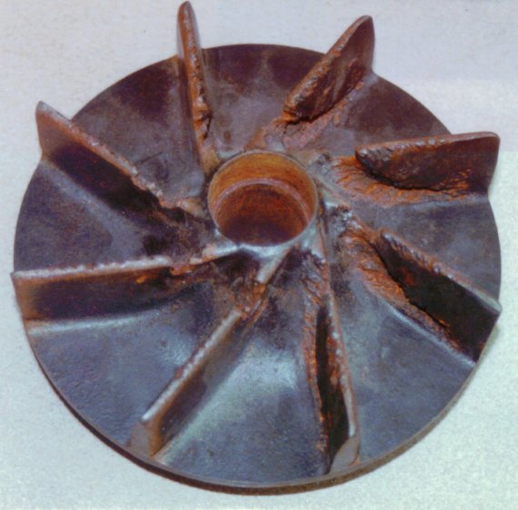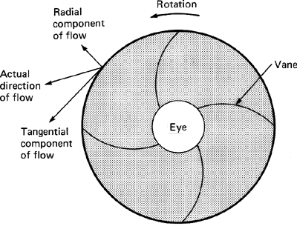

Models of Submersible Pump

A pump is first filled with water or the liquid to be lifted. Its impeller is then rotated by an external device, say an electric motor. The rotation of the impeller causes a forced vortex action on the fluid which results in increase of velocity and pressure of the fluid with radius and a partial vacuum near the impeller center, called its ‘eye’

Water or liquid from a sump is then sucked into the pump through a suction pipe connected to the pump casing at the inlet to the impeller eye and discharge with higher velocity and pressure at the impeller circumference. Note that a valve at the end of the suction pipe, called the foot-valve, is necessary so that the water poured in for priming is retained within the pump casing.

The high velocity of fluid at impeller outlet is further reduced and static pressure increased by a diffusing passage. In the simplest design, the diffusingpassage is pump casing whose area of cross-section is gradually increased up to the discharge pipe. The passage is called the ‘volute casing’. An improvement over the simple volute casing is the addition of a circular chamber of vaneless space between the impeller and the spiral chamber.

**4. Details Description of IDP**

Impeller types can be radial, mixed flow, axial and peripheral and are selected on the basis of the pump design and the application.

**Types of impeller**

|  |
| --- |
|  |
|  |
|  |
|  |
|  |
|  |
|  |
|  |

There are advantages and disadvantages of Open Impeller & Closed Impeller :­-

|  |  |
| --- | --- |
| **CLOSED IMPELLER** | **OPEN IMPELLER** |
| Can compensate for shaft thermal growth, but if there is too much axial growth the vanes may not line up exactly with the discharge nozzle. | The impeller to volute or back plate clearance must be adjusted when the pump is at operating temperature and all axial thermal growth has occurred |
| Good for volatile and explosive fluids because the close clearance wear rings are the parts that will contact if the shaft displaces from its centerline | You would have to use soft, non-sparking materials for the impeller and that is not very practical. |
| The impeller is initially very efficient, but looses its efficiency as the wear ring clearance increases | Efficiency can be maintained through impeller clearance adjustment. |
| No impeller adjustment is possible. Once the wear ring clearances doubles they have to be replaced. This means the pump had to be disassembled just to check the status of the wear rings. | The impeller can be adjusted to compensate for wear and stay close to its best efficiency. No pump disassembly is necessary. |
| The impeller can clog if you pump solids or "stringy material". It's difficult to clean out these solids from between the shrouds and vanes. | The open impeller is less likely to clog with solids, but if it does, it is easy to clean. |
| The impeller is difficult to cast because the internal parts are hidden and hard to inspect for flaws | The open impeller has all the parts visible, so it's easy to inspect for wear or damage |
| The closed impeller is a more complicated and expensive design not only because of the impeller, but the additional wear rings are needed. | The pump is less costly to build with a simple open impeller design. |
| The impeller is difficult to modify to improve its performance. | The vanes can easily be cut or filed to increase the capacity. |
| The specific speed choices (the shape of the impeller) are limited | You have a greater range of specific speed choices. |

**Impellers can be designed for a variety of applications:**

* The ideal impeller would have an infinite number of vanes of an infinitesimal size.
* The conventional impeller design with sharp vane edges and restricted areas is not suitable for handling liquids that contain rags, stringy materials and solids like sewage because it will clog. Special non-clogging impellers with blunt edges and large water ways have been developed for these services.
* Paper pulp impellers are fully open and non-clogging. The screw conveyer end projects far into the suction nozzle permitting the pump to handle high consistency paper pulp stock.
* Vortex pump designs have recessed impellers that pump the solids by creating a vortex (whirl pool effect) in the volute and the solids move without ever coming into contact with the impeller. You pay for this feature with a greater loss of pump efficiency.
* An axial flow impeller called an Inducer (it works like a booster pump) can be placed ahead of the regular pump impeller, on the same shaft, to increase the suction pressure and lessen the chance of cavitation. In some instances this can allow the pump to operate at a higher speed with a given NPSH. The inducer will contribute less than 5% of the total pump head, and although low in efficiency the total efficiency of the pump is not reduced significantly. The total reduction in NPSH required can be as much as 50%.

**5**. **EXPECTED OUTCOME**

**Merits of Plastic Impeller Of Pumps:**

1. No doubt the recycling of plastic consume more energy and effort compare to its manufacturing but it is a good alternate to prevent the plastic pollution in environment.
2. Plastic materials are light in weight, unbreakable, odorless and can be easily moulded.
3. They have excellent finishing; possess good shock absorption capacity, high strength as well as toughness.
4. The plastics materials are corrosion resistant and these are inert as far chemical or changes due to atmospheric oxygen goes; besides these have low thermal expansion of co-efficient.
5. Plastics have water resistant property and possess good adhesiveness. They are strong, durable, good and cheap to produce
6. It is possible to recycle plastic; therefore no decomposition required which is much more expensive and hazardous than recycling.
7. Plastic can be used in building, construction, electronics, packing and transportation industries.

**Impellers can be designed for a variety of applications:**

* The ideal impeller would have an infinite number of vanes of an infinitesimal size.
* The conventional impeller design with sharp vane edges and restricted areas is not suitable for handling liquids that contain rags, stringy materials and solids like sewage because it will clog. Special non-clogging impellers with blunt edges and large water ways have been developed for these services.
* Paper pulp impellers are fully open and non-clogging. The screw conveyer end projects far into the suction nozzle permitting the pump to handle high consistency paper pulp stock.
* Vortex pump designs have recessed impellers that pump the solids by creating a vortex (whirl pool effect) in the volute and the solids move without ever coming into contact with the impeller. You pay for this feature with a greater loss of pump efficiency.

**Polymer Impellers Prove Impervious to Cavitation, Erosion, and Corrosion:-**

Intech’s impellers, valvles, seals, and pumps are impervious to corrosion, erosion and cavitation. That means that Intech Power-Core Impellers never corrode in Salt Water, Waste Water, or Chlorinated water or other chemicals or petroliums. Intech engineers have developed complex life calculations of their components of the last 30 years and can accurately predict the life expectancy and total cycles of parts can achieve.

**Advantages of Power-Core Impellers:**

1. 8 times lighter than Stainless Steel(radical improvements in energy efficentcy)
2. Tremendous Mechanical Strength
3. Corrosion Resistant
4. Erosion Resistant
5. Cavitation Resistant
6. Eliminate Balance Problems
7. Eliminate Electrolysis
8. Prevent Catastrophic Failur
9. Can Start the Pump Dry

Intech’s impellers, valvles, seals, and pumps are impervious to corrosion, erosion and cavitation.   
That means that Intech Power-Core Impellers never corrode in Salt Water, Waste Water, or Chlorinated water or other chemical applications. Intech engineers have developed complex life calculations of their components of the last 30 years and can accurately predict the life expectancy and total cycles of their components.

Power-Core impellers are 100% cast out of a propriety formula that yields the only grade of non hygroscopic nylon named Intech Power-core. Intech’s proprietary material offers higher Mechanical Strength, ideal Balance, enhanced Performance, Smooth & even Surfaces, and ultimately  Longer Life.

Intech Power-core Impellers are engineered and precision cast. The impeller vane geometry can be designed to maximize efficiency and performance. This attention to engineering can eliminate problems caused by cavitation, recirculation, and radial thrust. The efficient production methodology of Power-core permits for Impeller Vane shapes to be easily modified allowing for specific application and performance requests.

**Power-Core Polymer Impellers Resist Cavitation, Corrosion, and Erosion:-**

Power-core  impellers are cast into near net shapes - reducing the machining cost of traditional fiber reinforeced phenolic components. The unique balance of properties of our impellers allows them outlast and outperform metal and composite impellers.

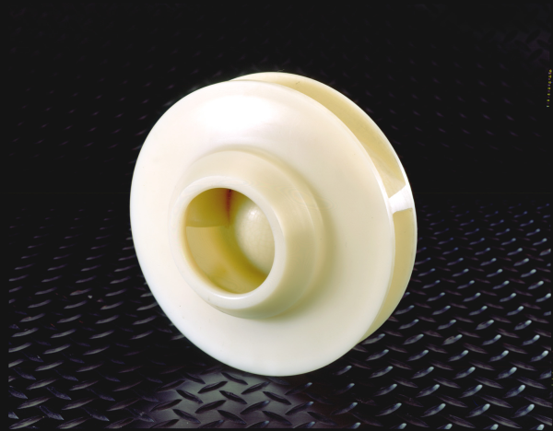

For 30 years Intech has been a  leader self-lubricating components for power transmission and motion applications . Recent studies by Intech’s RD department have yielded insights into an innovative pump solution for the Marine and Industrial markets.Intech’s impellers, valvles, seals, and pumps are impervious to corrosion, erosion and cavitation.

That means that Intech Power-Core Impellers never corrode in Salt Water, Waste Water, or Chlorinated water or many other chemical applications. Intech engineers have developed complex life calculations of plastics of the last 30 years and can accurately predict the life expectancy

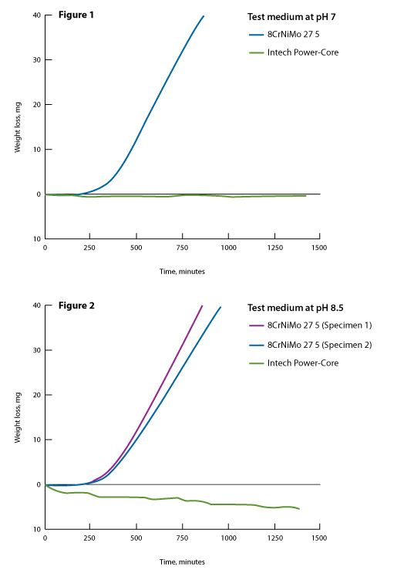

Power-Core impellers are cast out of a propriety formula that yields the only grade of non hygroscopic cast nylon named Intech Power-core. Intech’s proprietary material offers higher mechanical strength, ideal balance, enhanced performance, smooth & even surfaces, and ultimately longer life.

**Some advantages include:**

1. Corrosion Resistant and Chemical Resistant
2. Never Corrode in Salt water – Waste water – Chlorinated water – Petroleum applications
3. Power-Core Impellers are Cavitation and Erosion Resistant (see the image below)
4. Intech Power-core Impellers are 1/7 th the weight of Steel or Bronze. That means that, because of the strength to weight ratio of the Power-Core Material, Intech impellers require less energy to run – have a smaller moment of inertia (less start up load), can improve bearing and mechanical seal life, and ultimately produce less vibration and shaft deflection – reducing the costs of replacing a bent or broken shaft or the noise of an impeller running out of alignment.
5. Intech Impellers are cast to near net shapes and thanks of the Power-core material properties yield a perfect balance and maintain that balance over the life of the pump
6. Eliminate electrolysis: Power-core is an inert cast monomer and does not conduct elctrolysis and thereby prologs the life of metallic pump casings.
7. Tighter Seals – Powercore seals will not gall or seize like metallic or composite based rings, therefore they can operate in tighter clearances permitting less leakage through the rings and impellers which additionally increases pump efficiency. Intech casing rings seal the casing preventing “wash out” of the casing ring landing areas that is a common maintenance problem with centrifugal pumps.
8. Reduces noise and vibration – Because of the extremely tight tolerances achieved through the proprietary power-core casting process – Power-Core impellers are light weight and exhibit excellent vibration dampening and noise absorbing qualities. This ultimately reduces noise and vibration in the pump better than any other material on the market.

**Impellers cast from powercore offer tremendous advantages over traditional impellers cast from metal:**

1. 7 times lighter than metal
2. Tremendous Mechanical Strength
3. Corrosion Resistant
4. Erosion Resistant
5. Cavitation Resistant
6. Outlast & Outperforms – stainless steel, bronze, duplex steel, monel and even titanium
7. Lower Total cost because of net casting process and years of trouble free performance

**Industries that would benefit from Intech Power-Core Impellers and Seals Are:**

1. Marine
2. Navy
3. Industrial (Submarsibal Pump)
4. Oil & Gas
5. Chemical Industries

**6. Conclusion**

1. After completion of project part-I the skill for problem definition has been developed and we started to think about the real problem.
2. We studied the problem in detatil and quote some expected thoughts for problem solution of thrust bearing and stamping of submercible pump.
3. During this study we learn how to face the real technical problem and its effect to the industry and community in terms of life of product and economy of product.
4. Project-1 can give us opportunity’s to familiar with industries environment and enhance the knowledge of production process and also know the requirements of proper production planning and control.

**7. References:**

**WEBSITES:**

1.WWW.NAPTUNE-INDIA.COM

2.WWW.GOOGLE.COM

•PHOTOS OF SUBMERSIBLEPUMP AND MOTORS.

3.WWW.WIKIPEDIA.COM

•DETAILS ABOUT PUMPS

4.KNOWLEDGE-3.HTML

5.WWW.MECHANICAL-PRO.COM

6.WWW.SCINCESDiRECT.COM

7.WWW.SUBMERSIBLEPUMP.NET/KNOWLEDGE.HTML

•PUMPING FACTOR

•SUBMERSIBLE PUMP TECHNOLOGY

•SUBMERSIBLEMOTOR TECHNOLOGY

**BOOKS:**

1.FLUID MECHANICS AND HYDROULIC DEVICES

•DEFINITION OF SUBMERSIBLE PUMP

•WORKING PRINCIPLE OF SUBMERSIBLE PUMP

•APPLICATIONS OF SUBMERSIBLE PUMP

•ADVANTAGES OF SUBMERSIBLE PUMP

•SAFETY OF SUBMERSIBLE PUMP

•MAINTANANCE TABLE OF SUBMERSIBLE PUMP